**CAREERS AND COMMUNITY – Programme of Study**

**Meeting the statutory PSHE curriculum**

**Intent**

#### At Gildredge House we encompass Personal, Social, Health and Economic education (PSHEE), Relationship and Sex Education (RSE) and Careers into a timetabled lessons called Careers and Community.

The intent of our Careers and Community curriculum is to deliver a curriculum which is accessible to all and that will maximise the outcomes for every child. As a result of this, students will become healthy, independent and responsible members of a society who understand how they are developing personally and socially and give them confidence to tackle many of the moral, social and cultural issues that are a part of growing up. We provide our students with the necessary skills to respond effectively to economic and political changes as well as changing patterns of work, and equip students for their adult roles in society, helping them to understand the responsibilities of being parents, citizens and consumers.

We provide our students with opportunities to learn about rights and responsibilities and appreciate what it means to be a member of a diverse society. Our students are encouraged to develop their sense of self-worth by playing a positive role in contributing to school life and the wider community. Our school ethos supports this through encouraging our students to be Ready, Respectful and Safe.

Most of PSHE education becomes statutory for all schools from September 2020 under the Children and Social Work Act 2017. This includes Relationships Education at key stages 1 and 2, Relationships and Sex Education (RSE) at key stages 3 and 4, and Health Education in both primary and secondary phases.

The Department for Education published [Statutory Guidance for Relationships Education, Relationships and Sex Education (RSE) and Health Education](https://www.gov.uk/government/publications/relationships-education-relationships-and-sex-education-rse-and-health-education) in June 2019. This sets out what schools *must* cover from September 2020 (though not all they *should* cover as part of broader PSHE education).

This Programme of Study sets out learning opportunities for key stage 1 to 5, based on three core themes:

* Core theme 1: Health and Wellbeing
* Core theme 2: Relationships
* Core theme 3: Living in the wider world

**Implimentation**

Careers and Community cannot always be confined to specific timetabled time. Delivery of learning is a whole-school approach.

This includes:

* discrete curriculum time delivered by specialist teams, Form Tutors and other staff;
* teaching PSHEE through and in other subject / curriculum areas;
* through PSHEE activities and school focus days or events; and
* through pastoral care and guidance.

At Gildredge House, students have one lesson per week focusing on Life-related matters, including Careers Education and Guidance, Sex and Drugs / Alcohol Education, Personal Social and Health education as well as Financial Capability.

Formal Assemblies and Form Tutor time are used to deliver aspects of the Life programme e.g. Anti-Bullying.

Careers and Community endeavours to help students to lead confident, healthy and responsible lives as individuals and members of society.

Our bespoke programme at Secondary and Sixth Form builds from the Jigsaw programme delivered in Primary. The curriculum allows students to engage in a range of activities across and beyond the curriculum; students gain practical knowledge and skills to help them live healthily and deal with the spiritual, moral, social and cultural issues they may face as they approach adulthood.

Careers and Community gives students opportunities to reflect on their experiences and how they are developing. It helps them to understand and manage responsibly a wider range of relationships as they mature and to show respect for the diversity of and differences between people.

It also develops students’ well-being and self-esteem encouraging belief in their ability to succeed and enabling them to take responsibility for their learning and future choice of courses and career. Careers and Community builds on the students’ own experiences and work done in the Primary phase. It also compliments Life lessons in the school curriculum, covering areas such as issues in politics, the law, family, the environment, relationships, British Values, e-safety, self-awareness and the media.

[Primary PSHEE and RSE - Gildredge House School](https://www.gildredgehouse.org.uk/home/curriculum/primary-curriculum/primary-pshee-and-rse/)

[Secondary PSHEE and Careers - Gildredge House School](https://www.gildredgehouse.org.uk/home/curriculum/secondary-curriculum/secondary-pshee-and-careers/)

|  |  |  |
| --- | --- | --- |
| Careers | Community | Relationship and Sex Education |
| The Careers Education programme at Gildredge House helps students make the most of themselves and their opportunities. In particular, it aims to help students: maintain a culture of high aspirations; develop their knowledge and understanding of the changing nature of work; learning and careers; develop the skills and attitudes necessary for success in modern Britain; develop in students an awareness of the wide variety of education, training and careers opportunities both locally and nationally; extend their understanding of opportunities in learning and work; develop an awareness of the range of opportunities which are realistically available to them in continued education and training at 16+ and 18+; assess their achievements, qualities and skills; develop the necessary decision-making skills to manage transitions; experience the world of work and develop transferable skills; make good use of information and guidance by all members of staff at Gildredge House; recognise and deal accordingly with influences on their attitudes, values and behaviour in relation to work; develop and use their self-knowledge when thinking about course choices; recognise the value and impact their activities at school can have on their future; and develop and use the skills they need to review achievements, plan future actions, make decisions, present themselves well and cope with change and transition. | Within Community we cover all aspects of the statutory Personal, Social, Health and Economic Education (PSHEE) curriculum. We aim to support students: To create a cohesive learning community through the promotion of our students’ spiritual, moral, social and cultural development and their physical, social and emotional well-being. To enable all students to develop as fully as possible their interests, abilities and aptitudes and to make additional provision for those who are in any way disadvantaged. To allow students to develop lively, inquisitive minds so that they can be capable of independent thought and formulate their own opinions. To experience enjoyment of learning so that they may be encouraged to take advantage of educational opportunities later in life. To develop appropriate skills in literacy and numeracy. To develop programmes of study and experiences which will enhance students’ self-respect and confidence and encourage them to take responsibility for themselves and their actions. To provide students with the necessary skills to respond effectively to social, economic and political changes as well as changing patterns of work. To develop social skills that are necessary to work successfully with other people both inside and outside of the school environment. To equip students for their adult roles in society and help them to understand the responsibilities of being parents, citizens and consumers. To encourage appreciation of, and concern for, the environment. To develop interests and skills that will continue to give personal satisfaction in the use of leisure time. To establish partnerships between the school and the community it serves and help to develop an understanding of the wider community and the ways in which individuals and school relate. To develop a curriculum which enhances students’ knowledge and experience and allows them to learn about themselves and the society in which they live, through a variety of social and moral issues. To provide students with the experience of school as a caring, supportive community where life is enjoyable and there is equal provision of opportunity, regardless of gender, race, culture or ability. To enable students to make informed choices when considering the development of a healthy and safer lifestyle. To give students the confidence to discuss difficult issues by encouraging non-judgemental participation by students and staff. | RSE plays a very important part in fulfilling the statutory duties all schools have to meet. RSE helps students understand the difference between safe and abusive relationships and equips them with the skills to get help if they need it. Our aims are:   To enable young people to understand and respect their bodies, and be able to cope with the changes puberty brings, without fear or confusion. To help young people develop positive and healthy relationships appropriate to their age, development, etc. (respect for self and others). To support young people to have positive self-esteem and body image, and to understand the influences and pressures around them. To empower them to be safe and safeguarded. To clarify/reinforce existing knowledge. To raise students’ self-esteem and confidence, especially in their relationships with others. To help students understand their sexual feelings and behaviour, so they can lead fulfilling and enjoyable lives. To help students develop skills (language, decision making, choice, assertiveness) and make the most of their abilities. To provide the confidence to be participating members of society and to value themselves and others. To help gain access to information and support. To develop skills for a healthier safer lifestyle. To develop and use communication skills and assertiveness skills to cope with the influences of their peers and the media. To respect and care for their bodies. To be prepared for puberty and adulthood. |

**Covering the statutory content**

The statutory guidance is comprehensively covered by learning opportunities across all three core themes. Even though much of ‘Living in the wider world’ is not included in statutory requirements, the theme as a whole remains vitally important for pupils’ personal development and economic wellbeing, as well as in supporting schools to meet the Gatsby Benchmarks for careers education as part of the [DfE Careers Strategy](https://www.gov.uk/government/publications/careers-strategy-making-the-most-of-everyones-skills-and-talents).

The final section of the Programme of Study sets out the content grids from the Statutory Guidance for Relationships Education, RSE and Health Education, mapped to the Programme of Study, clearly identifying the Programme of Study learning opportunities that address each bullet point from the statutory guidance.

**The programme of study**

The Programme of Study sets out learning opportunities for each key stage, in each core theme, organised under subheadings. These learning opportunities should be used flexibly to plan your programme according to pupils’ development, readiness and needs, and taking into account prior learning, experience and understanding.

Learning from one area may be related and relevant to others. Whilst this framework distinguishes three separate core themes, there will be extensive overlap, so when planning schemes of work, schools may draw from more than one theme. For example, Relationships and Sex Education (RSE) falls within both ‘Health and Wellbeing’ and ‘Relationships’, as sexual health should always be considered as an element of health education but also taught within the context of healthy relationships. Similarly, whilst they are specifically addressed where appropriate, assessing and managing risk and managing life online are integrated throughout all three core themes.

PSHE education addresses both pupils’ current experiences and preparation for their future. The Programme of Study therefore provides a spiral curriculum to develop knowledge, skills and attributes, where prior learning is revisited, reinforced and extended year on year. This is grounded in the established evidence base for effective practice in PSHE education.

KEY STAGE 1-2

During key stages 1 and 2, PSHE education offers both explicit and implicit learning opportunities and experiences which reflect pupils’ increasing independence and physical and social awareness, as they move through the primary phase. It builds on the skills that pupils started to acquire during the Early Years Foundation stage (EYFS) to develop effective relationships, assume greater personal responsibility and manage personal safety, including online. PSHE education helps pupils to manage the physical and emotional changes at puberty, introduces them to a wider world and enables them to make an active contribution to their communities.

#### CORE THEME 1: HEALTH AND WELLBEING

|  |  |
| --- | --- |
| **KS1** Learning opportunities in Health and Wellbeing  *Students will know…* | **KS2** Learning opportunities in Health and Wellbeing  *Students will know…* |
| **Healthy lifestyles (physical wellbeing)** | |
| **H1.** about what keeping healthy means; different ways to keep healthy  **H2.** about foods that support good health and the risks of eating too much sugar  **H3.** about how physical activity helps us to stay healthy; and ways to be physically active everyday  **H4.** about why sleep is important and different ways to rest and relax  **H5.** simple hygiene routines that can stop germs from spreading  **H6.** that medicines (including vaccinations and immunisations and those that support allergic reactions) can help people to stay healthy  **H7.** about dental care and visiting the dentist; how to brush teeth correctly; food and drink that support dental health  **H8.** how to keep safe in the sun and protect skin from sun damage  **H9.** about different ways to learn and play; recognising the importance of knowing when to take a break from time online or TV  **H10.** about the people who help us to stay physically healthy | **H1.** how to make informed decisions about health  **H2.** about the elements of a balanced, healthy lifestyle  **H3.** about choices that support a healthy lifestyle, and recognise what might influence these  **H4.** how to recognise that habits can have both positive and negative effects on a healthy lifestyle  **H5.** about what good physical health means; how to recognise early signs of physical illness  **H6.** about what constitutes a healthy diet; how to plan healthy meals; benefits to health and wellbeing of eating nutritionally rich foods; risks associated with not eating a healthy diet including obesity and tooth decay.  **H7.** how regular (daily/weekly) exercise benefits mental and physical health (e.g. walking or cycling to school, daily active mile); recognise opportunities to be physically active and some of the risks associated with an inactive lifestyle  **H8.** about how sleep contributes to a healthy lifestyle; routines that support good quality sleep; the effects of lack of sleep on the body, feelings, behaviour and ability to learn  **H9.** that bacteria and viruses can affect health; how everyday hygiene routines can limit the spread of infection; the wider importance of personal hygiene and how to maintain it  **H10.** how medicines, when used responsibly, contribute to health; that some diseases can be prevented by vaccinations and immunisations; how allergies can be managed  **H11.** how to maintain good oral hygiene (including correct brushing and flossing); why regular visits to the dentist are essential; the impact of lifestyle choices on dental care (e.g. sugar consumption/acidic drinks such as fruit juices, smoothies and fruit teas; the effects of smoking)  **H12.** about the benefits of sun exposure and risks of overexposure; how to keep safe from sun damage and sun/heat stroke and reduce the risk of skin cancer  **H13.** about the benefits of the internet; the importance of balancing time online with other activities; strategies for managing time online  **H14.** how and when to seek support, including which adults to speak to in and outside school, if they are worried about their health |

|  |  |
| --- | --- |
| **Mental Health** | |
| **H11.** about different feelings that humans can experience  **H12.** how to recognise and name different feelings  **H13.** how feelings can affect people’s bodies and how they behave  **H14.** how to recognise what others might be feeling  **H15.** to recognise that not everyone feels the same at the same time, or feels the same about the same things  **H16.** about ways of sharing feelings; a range of words to describe feelings  **H17.** about things that help people feel good (e.g. playing outside, doing things they enjoy, spending time with family, getting enough sleep)  **H18.** different things they can do to manage big feelings, to help calm themselves down and/or change their mood when they don’t feel good  **H19.** to recognise when they need help with feelings; that it is important to ask for help with feelings; and how to ask for it  **H20.** about change and loss (including death); to identify feelings associated with this; to recognise what helps people to feel better | **H15.** that mental health, just like physical health, is part of daily life; the importance of taking care of mental health  **H16.** about strategies and behaviours that support mental health — including how good quality sleep, physical exercise/time outdoors, being involved in community groups, doing things for others, clubs, and activities, hobbies and spending time with family and friends can support mental health and wellbeing  **H17.** to recognise that feelings can change over time and range in intensity  **H18.** about everyday things that affect feelings and the importance of expressing feelings  **H19.** a varied vocabulary to use when talking about feelings; about how to express feelings in different ways;  **H20.** strategies to respond to feelings, including intense or conflicting feelings; how to manage and respond to feelings appropriately and proportionately in different situations  **H21.** to recognise warning signs about mental health and wellbeing and how to seek support for themselves and others  **H22.** to recognise that anyone can experience mental ill health; that most difficulties can be resolved with help and support; and that it is important to discuss feelings with a trusted adult  **H23.** about change and loss, including death, and how these can affect feelings; ways of expressing and managing grief and bereavement  **H24.** problem-solving strategies for dealing with emotions, challenges and change, including the transition to new schools |
| **Ourselves, growing and changing** | |
| **H21.** to recognise what makes them special  **H22.** to recognise the ways in which we are all unique  **H23.** to identify what they are good at, what they like and dislike  **H24.** how to manage when finding things difficult  **H25.** to name the main parts of the body including external genitalia (e.g. vulva, vagina, penis, testicles)  **H26.** about growing and changing from young to old and how people’s needs change  **H27.** about preparing to move to a new class/year group | **H25.** about personal identity; what contributes to who we are (e.g. ethnicity, family, gender, faith, culture, hobbies, likes/dislikes)  **H26.** that for some people gender identity does not correspond with their biological sex  **H27.** to recognise their individuality and personal qualities  **H28.** to identify personal strengths, skills, achievements and interests and how these contribute to a sense of self-worth  **H29.** about how to manage setbacks/perceived failures, including how to re-frame unhelpful thinking  **H30.** to identify the external genitalia and internal reproductive organs in males and females and how the process of puberty relates to human reproduction  **H31.** about the physical and emotional changes that happen when approaching and during puberty (including menstruation, key facts about the menstrual cycle and menstrual wellbeing, erections and wet dreams)  **H32.** about how hygiene routines change during the time of puberty, the importance of keeping clean and how to maintain personal hygiene  **H33.** about the processes of reproduction and birth as part of the human life cycle; how babies are conceived and born (and that there are ways to prevent a baby being made); how babies need to be cared for¹  **H34.** about where to get more information, help and advice about growing and changing, especially about puberty  **H35.** about the new opportunities and responsibilities that increasing independence may bring  **H36.** strategies to manage transitions between classes and key stages |
| **Keeping safe** | |
| **H28.** about rules and age restrictions that keep us safe  **H29.** to recognise risk in simple everyday situations and what action to take to minimise harm  **H30.** about how to keep safe at home (including around electrical appliances) and fire safety (e.g. not playing with matches and lighters)  **H31.** that household products (including medicines) can be harmful if not used correctly  **H32.** ways to keep safe in familiar and unfamiliar environments (e.g. beach, shopping centre, park, swimming pool, on the street) and how to cross the road safely  **H33.** about the people whose job it is to help keep us safe  **H34.** basic rules to keep safe online, including what is meant by personal information and what should be kept private; the importance of telling a trusted adult if they come across something that scares them  **H35.** about what to do if there is an accident and someone is hurt  **H36.** how to get help in an emergency (how to dial 999 and what to say) | **H37.** reasons for following and complying with regulations and restrictions (including age restrictions); how they promote personal safety and wellbeing with reference to social media, television programmes, films, games and online gaming  **H38.** how to predict, assess and manage risk in different situations  **H39.** about hazards (including fire risks) that may cause harm, injury or risk in the home and what they can do to reduce risks and keep safe  **H40.** about the importance of taking medicines correctly and using household products safely, (e.g. following instructions carefully)  **H41.** strategies for keeping safe in the local environment or unfamiliar places (rail, water, road) and firework safety; safe use of digital devices when out and about  **H42.** about the importance of keeping personal information private; strategies for keeping safe online, including how to manage requests for personal information or images of themselves and others; what to do if frightened or worried by something seen or read online and how to report concerns, inappropriate content and contact  **H43.** about what is meant by first aid; basic techniques for dealing with common injuries  **H44.** how to respond and react in an emergency situation; how to identify situations that may require the emergency services; know how to contact them and what to say  **H45.** that female genital mutilation (FGM) is against British law, what to do and whom to tell if they think they or someone they know might be at risk |
| **Drugs, alcohol and tobacco** | |
| **H37.** about things that people can put into their body or on their skin; how these can affect how people feel | **H46.** about the risks and effects of legal drugs common to everyday life (e.g. cigarettes, e-cigarettes/vaping, alcohol and medicines) and their impact on health; recognise that drug use can become a habit which can be difficult to break  **H47.** to recognise that there are laws surrounding the use of legal drugs and that some drugs are illegal to own, use and give to others  **H48.** about why people choose to use or not use drugs (including nicotine, alcohol and medicines);  **H49.** about the mixed messages in the media about drugs, including alcohol and smoking/vaping  **H50.** about the organisations that can support people concerning alcohol, tobacco and nicotine or other drug use; people they can talk to if they have concerns |

#### CORE THEME 2: RELATIONSHIPS

|  |  |
| --- | --- |
| **KS1** Learning opportunities in Health and Wellbeing  *Students will know…* | **KS2** Learning opportunities in Health and Wellbeing  *Students will know…* |
| **Families and close positive relationships** | |
| **R1.** about the roles different people (e.g. acquaintances, friends and relatives) play in our lives  **R2.** to identify the people who love and care for them and what they do to help them feel cared for  **R3.** about different types of families including those that may be different to their own  **R4.** to identify common features of family life R5. that it is important to tell someone (such as their teacher) if something about their family makes them unhappy or worried | **R1.** to recognise that there are different types of relationships (e.g. friendships, family relationships, romantic relationships, online relationships)  **R2.** that people may be attracted to someone emotionally, romantically and sexually; that people may be attracted to someone of the same sex or different sex to them; that gender identity and sexual orientation are different  **R3.** about marriage and civil partnership as a legal declaration of commitment made by two adults who love and care for each other, which is intended to be lifelong  **R4.** that forcing anyone to marry against their will is a crime; that help and support is available to people who are worried about this for themselves or others  **R5.** that people who love and care for each other can be in a committed relationship (e.g. marriage), living together, but may also live apart  **R6.** that a feature of positive family life is caring relationships; about the different ways in which people care for one another  **R7.** to recognise and respect that there are different types of family structure (including single parents, same-sex parents, step-parents, blended families, foster parents); that families of all types can give family members love, security and stability  **R8.** to recognise other shared characteristics of healthy family life, including commitment, care, spending time together; being there for each other in times of difficulty  **R9.** how to recognise if family relationships are making them feel unhappy or unsafe, and how to seek help or advice |

|  |  |
| --- | --- |
| **Friendships** | |
| **R6.** about how people make friends and what makes a good friendship  **R7.** about how to recognise when they or someone else feels lonely and what to do  **R8.** simple strategies to resolve arguments between friends positively  **R9.** how to ask for help if a friendship is making them feel unhappy | **R10.** about the importance of friendships; strategies for building positive friendships; how positive friendships support wellbeing  **R11.** what constitutes a positive healthy friendship (e.g. mutual respect, trust, truthfulness, loyalty, kindness, generosity, sharing interests and experiences, support with problems and difficulties); that the same principles apply to online friendships as to face-to-face relationships  **R12.** to recognise what it means to ‘know someone online’ and how this differs from knowing someone face-to-face; risks of communicating online with others not known face-to-face  **R13.** the importance of seeking support if feeling lonely or excluded  **R14.** that healthy friendships make people feel included; recognise when others may feel lonely or excluded; strategies for how to include them  **R15.** strategies for recognising and managing peer influence and a desire for peer approval in friendships; to recognise the effect of online actions on others  **R16.** how friendships can change over time, about making new friends and the benefits of having different types of friends  **R17.** that friendships have ups and downs; strategies to resolve disputes and reconcile differences positively and safely  **R18.** to recognise if a friendship (online or offline) is making them feel unsafe or uncomfortable; how to manage this and ask for support if necessary |
| **Managing hurtful behaviour and bullying** | |
| **R10.** that bodies and feelings can be hurt by words and actions; that people can say hurtful things online  **R11.** about how people may feel if they experience hurtful behaviour or bullying  **R12.** that hurtful behaviour (offline and online) including teasing, name-calling, bullying and deliberately excluding others is not acceptable; how to report bullying; the importance of telling a trusted adult | **R19.** about the impact of bullying, including offline and online, and the consequences of hurtful behaviour  **R20.** strategies to respond to hurtful behaviour experienced or witnessed, offline and online (including teasing, name-calling, bullying, trolling, harassment or the deliberate excluding of others); how to report concerns and get support  **R21.** about discrimination: what it means and how to challenge it |
| **Safe Relationships** | |
| **R13.** to recognise that some things are private and the importance of respecting privacy; that parts of their body covered by underwear are private  **R14.** that sometimes people may behave differently online, including by pretending to be someone they are not  **R15.** how to respond safely to adults they don’t know  **R16.** about how to respond if physical contact makes them feel uncomfortable or unsafe  **R17.** about knowing there are situations when they should ask for permission and also when their permission should be sought  **R18.** about the importance of not keeping adults’ secrets (only happy surprises that others will find out about eventually)  **R19.** basic techniques for resisting pressure to do something they don’t want to do and which may make them unsafe  **R20.** what to do if they feel unsafe or worried for themselves or others; who to ask for help and vocabulary to use when asking for help; importance of keeping trying until they are heard | **R22.** about privacy and personal boundaries; what is appropriate in friendships and wider relationships (including online);  **R23.** about why someone may behave differently online, including pretending to be someone they are not; strategies for recognising risks, harmful content and contact; how to report concerns  **R24.** how to respond safely and appropriately to adults they may encounter (in all contexts including online) whom they do not know  **R25.** recognise different types of physical contact; what is acceptable and unacceptable; strategies to respond to unwanted physical contact  **R26.** about seeking and giving permission (consent) in different situations  **R27.** about keeping something confidential or secret, when this should (e.g. a birthday surprise that others will find out about) or should not be agreed to, and when it is right to break a confidence or share a secret  **R28.** how to recognise pressure from others to do something unsafe or that makes them feel uncomfortable and strategies for managing this  **R29.** where to get advice and report concerns if worried about their own or someone else’s personal safety (including online) |

|  |  |
| --- | --- |
| **Respecting others and self** | |
| **R21.** about what is kind and unkind behaviour, and how this can affect others  **R22.** about how to treat themselves and others with respect; how to be polite and courteous  **R23.** to recognise the ways in which they are the same and different to others  **R24.** how to listen to other people and play and work cooperatively  **R25.** how to talk about and share their opinions on things that matter to them | **R30.** that personal behaviour can affect other people; to recognise and model respectful behaviour online  **R31.** to recognise the importance of self-respect and how this can affect their thoughts and feelings about themselves; that everyone, including them, should expect to be treated politely and with respect by others (including when online and/or anonymous) in school and in wider society; strategies to improve or support courteous, respectful relationships  **R32.** about respecting the differences and similarities between people and recognising what they have in common with others e.g. physically, in personality or background  **R33.** to listen and respond respectfully to a wide range of people, including those whose traditions, beliefs and lifestyle are different to their own  **R34.** how to discuss and debate topical issues, respect other people’s point of view and constructively challenge those they disagree with |

CORE THEME 3: LIVING IN THE WIDER WORLD

|  |  |
| --- | --- |
| **KS1** Learning opportunities in Health and Wellbeing  *Students will know…* | **KS2** Learning opportunities in Health and Wellbeing  *Students will know…* |
| **Shared responsibilities** | |
| **L1.** about what rules are, why they are needed, and why different rules are needed for different situations  **L2.** how people and other living things have different needs; about the responsibilities of caring for them  **L3.** about things they can do to help look after their environment | **L1.** to recognise reasons for rules and laws; consequences of not adhering to rules and laws  **L2.** to recognise there are human rights, that are there to protect everyone  **L3.** about the relationship between rights and responsibilities  **L4.** the importance of having compassion towards others; shared responsibilities we all have for caring for other people and living things; how to show care and concern for others  **L5.** ways of carrying out shared responsibilities for protecting the environment in school and at home; how everyday choices can affect the environment (e.g. reducing, reusing, recycling; food choices) |
| **Communities** | |
| **L4.** about the different groups they belong to  **L5.** about the different roles and responsibilities people have in their community  **L6.** to recognise the ways they are the same as, and different to, other people | **L6.** about the different groups that make up their community; what living in a community means  **L7.** to value the different contributions that people and groups make to the community  **L8.** about diversity: what it means; the benefits of living in a diverse community; about valuing diversity within communities  **L9.** about stereotypes; how they can negatively influence behaviours and attitudes towards others; strategies for challenging stereotypes  **L10.** about prejudice; how to recognise behaviours/actions which discriminate against others; ways of responding to it if witnessed or experienced |
| **Media literacy and digital resilience** | |
| **L7.** about how the internet and digital devices can be used safely to find things out and to communicate with others  **L8.** about the role of the internet in everyday life  **L9.** that not all information seen online is true | **L11.** recognise ways in which the internet and social media can be used both positively and negatively  **L12.** how to assess the reliability of sources of information online; and how to make safe, reliable choices from search results  **L13.** about some of the different ways information and data is shared and used online, including for commercial purposes  **L14.** about how information on the internet is ranked, selected and targeted at specific individuals and groups; that connected devices can share information  **L15.** recognise things appropriate to share and things that should not be shared on social media; rules surrounding distribution of images  **L16.** about how text and images in the media and on social media can be manipulated or invented; strategies to evaluate the reliability of sources and identify misinformation |
| **Economic well-being: Money** | |
| **L10.** what money is; forms that money comes in; that money comes from different sources  **L11.** that people make different choices about how to save and spend money  **L12.** about the difference between needs and wants; that sometimes people may not always be able to have the things they want  **L13.** that money needs to be looked after; different ways of doing this | **L17.** about the different ways to pay for things and the choices people have about this  **L18.** to recognise that people have different attitudes towards saving and spending money; what influences people’s decisions; what makes something ‘good value for money’  **L19.** that people’s spending decisions can affect others and the environment (e.g. Fair trade, buying single-use plastics, or giving to charity)  **L20.** to recognise that people make spending decisions based on priorities, needs and wants  **L21.** different ways to keep track of money  **L22.** about risks associated with money (e.g. money can be won, lost or stolen) and ways of keeping money safe  **L23.** about the risks involved in gambling; different ways money can be won or lost through gambling-related activities and their impact on health, wellbeing and future aspirations  **L24.** to identify the ways that money can impact on people’s feelings and emotions |
| **Economic well-being: Aspirations, work and career** | |
| **L14.** that everyone has different strengths  **L15.** that jobs help people to earn money to pay for things  **L16.** different jobs that people they know or people who work in the community do  **L17.** about some of the strengths and interests someone might need to do different jobs | **L25.** to recognise positive things about themselves and their achievements; set goals to help achieve personal outcomes  **L26.** that there is a broad range of different jobs/careers that people can have; that people often have more than one career/type of job during their life  **L27.** about stereotypes in the workplace and that a person’s career aspirations should not be limited by them  **L28.** about what might influence people’s decisions about a job or career (e.g. personal interests and values, family connections to certain trades or businesses, strengths and qualities, ways in which stereotypical assumptions can deter people from aspiring to certain jobs)  **L29.** that some jobs are paid more than others and money is one factor which may influence a person’s job or career choice; that people may choose to do voluntary work which is unpaid  **L30.** about some of the skills that will help them in their future careers e.g. teamwork, communication and negotiation  **L31.** to identify the kind of job that they might like to do when they are older  **L32.** to recognise a variety of routes into careers (e.g. college, apprenticeship, university) |

KEY STAGE 3-4

At **key stage 3**, students build on the knowledge and understanding, skills, attributes and values they have acquired and developed during the primary phase. PSHE education acknowledges and addresses the changes that young people experience, beginning with transition to secondary school, the challenges of adolescence and their increasing independence. It teaches the knowledge and skills which will equip them for the opportunities and challenges of life. Students learn to manage diverse relationships, their online lives, and the increasing influence of peers and the media.

At **key stage 4**, students deepen knowledge and understanding, extend and rehearse skills, and further explore attitudes, values and attributes acquired during key stage 3. PSHE education reflects the fact that students are moving towards an independent role in adult life, taking on greater responsibility for themselves and others.

#### CORE THEME 1: HEALTH AND WELLBEING

|  |  |
| --- | --- |
| **KS3** Learning opportunities in Health and Wellbeing  *Students will know…* | **KS4** Learning opportunities in Health and Wellbeing  *Students will know…* |
| **Healthy lifestyles (physical wellbeing)** | |
| **H1.** how we are all unique; that recognising and demonstrating personal strengths build self-confidence, self-esteem and good health and wellbeing  **H2.** to understand what can affect wellbeing and resilience (e.g. life changes, relationships, achievements and employment)  **H3.** the impact that media and social media can have on how people think about themselves and express themselves, including regarding body image, physical and mental health  **H4.** simple strategies to help build resilience to negative opinions, judgements and comments  **H5.** to recognise and manage internal and external influences on decisions which affect health and wellbeing | **H1.** to accurately assess their areas of strength and development, and where appropriate, act upon feedback  **H2.** how self-confidence self-esteem, and mental health are affected positively and negatively by internal and external influences and ways of managing this  **H3.** how different media portray idealised and artificial body shapes; how this influences body satisfaction and body image and how to critically appraise what they see and manage feelings about this  **H4.** strategies to develop assertiveness and build resilience to peer and other influences that affect both how they think about themselves and their health and wellbeing |

|  |  |
| --- | --- |
| **Mental Health and Emotional Well-being** | |
| **H6.** how to identify and articulate a range of emotions accurately and sensitively, using appropriate vocabulary  **H7.** the characteristics of mental and emotional health and strategies for managing these  **H8.** the link between language and mental health stigma and develop strategies to challenge stigma and misconceptions associated with help-seeking and mental health concerns  **H9.** strategies to understand and build resilience, as well as how to respond to disappointments and setbacks  **H10.** a range of healthy coping strategies and ways to promote wellbeing and boost mood, including physical activity, participation and the value of positive relationships in providing support  **H11.** the causes and triggers for unhealthy coping strategies, such as self-harm and eating disorders, and the need to seek help for themselves or others as soon as possible *[NB It is important to avoid teaching methods and resources that provide instruction on ways of self-harming, restricting food/inducing vomiting, hiding behaviour from others etc., or that might provide inspiration for pupils who are more vulnerable (e.g. personal accounts of weight change).]*  **H12.** how to recognise when they or others need help with their mental health and wellbeing; sources of help and support and strategies for accessing what they need | **H5.** the characteristics of mental and emotional health; to develop empathy and understanding about how daily actions can affect people’s mental health  **H6.** about change and its impact on mental health and wellbeing and to recognise the need for emotional support during life changes and/or difficult experiences  **H7.** a broad range of strategies — cognitive and practical — for promoting their own emotional wellbeing, for avoiding negative thinking and for ways of managing mental health concerns  **H8.** to recognise warning signs of common mental and emotional health concerns (including stress, anxiety and depression), what might trigger them and what help or treatment is available  **H9.** the importance of and ways to pre-empt common triggers and respond to warning signs of unhealthy coping strategies, such as self-harm and eating  disorders in themselves and others *[NB It is important to avoid teaching methods and resources that provide instruction on ways of self-harming, restricting food/ inducing vomiting, hiding behaviour from others etc., or that might provide inspiration for pupils who are more vulnerable (e.g. personal accounts of weight change).]*  **H10.** how to recognise when they or others need help with their mental health and wellbeing; to explore and analyse ethical issues when peers need help; strategies and skills to provide basic support and identify and access the most appropriate sources of help |
| **Healthy Lifestyles** | **Health Related decisions** |
| **H13.** the importance of, and strategies for, maintaining a balance between school, work, leisure, exercise, and online activities  **H14.** the benefits of physical activity and exercise for physical and mental health and wellbeing  **H15.** the importance of sleep and strategies to maintain good quality sleep  **H16.** to recognise and manage what influences their choices about physical activity  **H17.** the role of a balanced diet as part of a healthy lifestyle and the impact of unhealthy food choices  **H18.** what might influence decisions about eating a balanced diet and strategies to manage eating choices  **H19.** the importance of taking increased responsibility for their own physical health including dental check-ups, sun safety and self-examination (especially testicular self-examination in late KS3); the purpose of vaccinations offered during adolescence for individuals and society.  **H20.** strategies for maintaining personal hygiene, including oral health, and prevention of infection  **H21.** how to access health services when appropriate  **H22.** the risks and facts associated with female genital mutilation (FGM), its status as a criminal act and strategies to safely access support for themselves or others who may be at risk, or who have already been subject to FGM | **H11.** to make informed lifestyle choices regarding sleep, diet and exercise  **H12.** the benefits of having a balanced approach to spending time online  **H13.** to identify, evaluate and independently access reliable sources of information, advice and support for all aspects of physical and mental health  **H14.** about the health services available to people; strategies to become a confident user of the NHS and other health services; to overcome potential concerns or barriers to seeking help  **H15.** the purpose of blood, organ and stem cell donation for individuals and society1  **H16.** how to take increased personal responsibility for maintaining and monitoring health including cancer prevention, screening and self-examination  **H17.** to assess and manage risks associated with cosmetic and aesthetic procedures, including tattooing, piercings and the use of sunbeds  **H18.** the ways in which industries and advertising can influence health and harmful behaviours |
| **Drugs, alcohol and tobacco** | |
| **H23.** the positive and negative uses of drugs in society including the safe use of prescribed and over the counter medicines; responsible use of antibiotics  **H24.** to evaluate misconceptions, social norms and cultural values relating to drug, alcohol and tobacco use  **H25.** strategies to manage a range of influences on drug, alcohol and tobacco use, including peers  **H26.** information about alcohol, nicotine and other legal and illegal substances, including the short-term and long-term health risks associated with their use  **H27.** the personal and social risks and consequences of substance use and misuse including occasional use  **H28.** the law relating to the supply, use and misuse of legal and illegal substances  **H29.** about the concepts of dependence and addiction including awareness of help to overcome addictions | **H19.** the consequences of substance use and misuse for the mental and physical health and wellbeing of individuals and their families, and the wider consequences for communities  **H20.** wider risks of illegal substance use for individuals, including for personal safety, career, relationships and future lifestyle  **H21.** to identify, manage and seek help for unhealthy behaviours, habits and addictions including smoking cessation |
| **Managing Risk and Personal Safety** | |
| **H30.** how to identify risk and manage personal safety in increasingly independent situations, including online  **H31.** ways of assessing and reducing risk in relation to health, wellbeing and personal safety  **H32.** the risks associated with gambling and recognise that chance-based transactions can carry similar risks; strategies for managing peer and other influences relating to gambling  **H33.** how to get help in an emergency and perform basic first aid, including cardio-pulmonary resuscitation (CPR) and the use of defibrillators | **H22.** ways to identify risk and manage personal safety in new social settings, workplaces, and environments, including online  **H23.** strategies for identifying risky and emergency situations, including online; ways to manage these and get appropriate help, including where there may be legal consequences (e.g. drugs and alcohol, violent crime and gangs)  **H24.** to increase confidence in performing emergency first aid and life-saving skills, including cardio-pulmonary resuscitation (CPR) and the use of defibrillators  **H25.** to understand and build resilience to thinking errors associated with gambling (e.g. ‘gambler’s fallacy’) the range of gambling-related harms , and how to access support for themselves or others |
| Puberty and Sexual health | Sexual Health and Fertility |
| **H34.** strategies to manage the physical and mental changes that are a typical part of growing up, including puberty and menstrual wellbeing  **H35.** about the purpose, importance and different forms of contraception; how and where to access contraception and advice (see also Relationships)  **H36.** that certain infections can be spread through sexual activity and that barrier contraceptives offer some protection against certain sexually transmitted infections (STIs) | **H26.** the different types of intimacy — including online — and their potential emotional and physical consequences (both positive and negative)  **H27.** about specific STIs, their treatment and how to reduce the risk of transmission  **H28.** how to respond if someone has, or may have, an STI (including ways to access sexual health services)  **H29.** to overcome barriers, (including embarrassment and misconceptions) about sexual health and the use of sexual health services  **H30.** about healthy pregnancy and how lifestyle choices affect a developing foetus  **H31.** that fertility can vary in all people, changes over time (including menopause) and can be affected by STIs and other lifestyle factors  **H32.** about the possibility of miscarriage and support available to people who are not able to conceive or maintain a pregnancy  **H33.** about choices and support available in the event of an unplanned pregnancy, and how to access appropriate help and advice |

#### CORE THEME 2: Relationships

|  |  |
| --- | --- |
| **KS3** Learning opportunities in Health and Wellbeing  *Students will know…* | **KS4** Learning opportunities in Health and Wellbeing  *Students will know…* |
| **Positive Relationships** | |
| **R1.** about different types of relationships, including those within families, friendships, romantic or intimate relationships and the factors that can affect them  **R2.** indicators of positive, healthy relationships and unhealthy relationships, including online  **R3.** about the similarities, differences and diversity among people of different race, culture, ability, sex, gender identity, age and sexual orientation  **R4.** the difference between biological sex, gender identity and sexual orientation  **R5.** to recognise that sexual attraction and sexuality are diverse  **R6.** that marriage is a legal, social and emotional commitment that should be entered into freely, and never forced upon someone through threat or coercion  **R7.** how the media portrays relationships and the potential impact of this on people’s expectations of relationships  **R8.** that the portrayal of sex in the media and social media (including pornography) can affect people’s expectations of relationships and sex | **R1.** the characteristics and benefits of strong, positive relationships, including mutual support, trust, respect and equality  **R2.** the role of pleasure in intimate relationships, including orgasms  **R3.** to respond appropriately to indicators of unhealthy relationships, including seeking help where necessary  **R4.** the importance of stable, committed relationships, including the rights and protections provided within legally recognised marriages and civil partnerships and the legal status of other long-term relationships  **R5.** the legal rights, responsibilities and protections provided by the Equality Act 2010  **R6.** about diversity in romantic and sexual attraction and developing sexuality, including sources of support and reassurance and how to access them  **R7.** strategies to access reliable, accurate and appropriate advice and support with relationships, and to assist others to access it when needed  **R8.** to understand the potential impact of the portrayal of sex in pornography and other media, including on sexual attitudes, expectations and behaviours |
| **Relationships Values** | |
| **R9.** to clarify and develop personal values in friendships, love and sexual relationships  **R10.** the importance of trust in relationships and the behaviours that can undermine or build trust  **R11.** to evaluate expectations about gender roles, behaviour and intimacy within romantic relationships  **R12.** that everyone has the choice to delay sex, or to enjoy intimacy without sex | **R9.** to recognise, clarify and if necessary challenge their own values and understand how their values influence their decisions, goals and behaviours  **R10.** to understand a variety of faith and cultural practices and beliefs concerning relationships and sexual activity; to respect the role these might play in relationship values |
| **Forming and maintaining respectful relationships** | |
| **R13.** how to safely and responsibly form, maintain and manage positive relationships, including online  **R14.** the qualities and behaviours they should expect and exhibit in a wide variety of positive relationships (including in school and wider society, family and friendships, including online)  **R15.** to further develop and rehearse the skills of team working  **R16.** to further develop the skills of active listening, clear communication, negotiation and compromise  **R17.** strategies to identify and reduce risk from people online that they do not already know; when and how to access help  **R18.** to manage the strong feelings that relationships can cause (including sexual attraction)  **R19.** to develop conflict management skills and strategies to reconcile after disagreements  **R20.** to manage the influence of drugs and alcohol on decision-making within relationships and social situations  **R21.** how to manage the breakdown of a relationship (including its digital legacy), loss and change in relationships  **R22.** the effects of change, including loss, separation, divorce and bereavement; strategies for managing these and accessing support  **R23.** the services available to support healthy relationships and manage unhealthy relationships, and how to access them | **R11.** strategies to manage the strong emotions associated with the different stages of relationships  **R12.** to safely and responsibly manage changes in personal relationships including the ending of relationships  **R13.** ways to manage grief about changing relationships including the impact of separation, divorce and bereavement; sources of support and how to access them  **R14.** the opportunities and potential risks of establishing and conducting relationships online, and strategies to manage the risks  **R15.** the legal and ethical responsibilities people have in relation to online aspects of relationships  **R16.** to recognise unwanted attention (such as harassment and stalking including online), ways to respond and how to seek help  **R17.** ways to access information and support for relationships including those experiencing difficulties |
| **Consent** | |
| **R24.** that consent is freely given; that being pressurised, manipulated or coerced  to agree to something is not giving consent, and how to seek help in such circumstances  **R25.** about the law relating to sexual consent  **R26.** how to seek, give, not give and withdraw consent (in all contexts, including online)  **R27.** that the seeker of consent is legally and morally responsible for ensuring that consent has been given; that if consent is not given or is withdrawn, that decision should always be respected  **R28.** to gauge readiness for sexual intimacy  **R29.** the impact of sharing sexual images of others without consent  **R30.** how to manage any request or pressure to share an image of themselves or others, and how to get help  **R31.** that intimate relationships should be pleasurable | **R18.** about the concept of consent in maturing relationships  **R19.** about the impact of attitudes towards sexual assault and to challenge victim- blaming, including when abuse occurs online  **R20.** to recognise the impact of drugs and alcohol on choices and sexual behaviour  **R21.** the skills to assess their readiness for sex, including sexual activity online, as an individual and within a couple  **R22.** to evaluate different motivations and contexts in which sexual images are shared, and possible legal, emotional and social consequences |
| **Contraception and parenthood** | |
| **R32.** the communication and negotiation skills necessary for contraceptive use in healthy relationships (see also ‘Health’)  **R33.** the risks related to unprotected sex  **R34.** the consequences of unintended pregnancy, sources of support and the options available  **R35.** the roles and responsibilities of parents, carers and children in families  **R36.** the nature and importance of stable, long-term relationships (including marriage and civil partnerships) for family life and bringing up children | **R23.** how to choose and access appropriate contraception (including emergency contraception) and negotiate contraception use with a partner  **R24.** the physical and emotional responses people may have to unintended pregnancy; the different options available; whom to talk to for accurate, impartial advice and support  **R25.** the importance of parenting skills and qualities for family life, the implications of young parenthood and services that offer support for new parents and families  **R26.** the reasons why people choose to adopt/foster children  **R27.** about the current legal position on abortion and the range of beliefs and opinions about it |
| **Bullying, Abuse and discrimination** | |
| **R37.** the characteristics of abusive behaviours, such as grooming, sexual harassment, sexual and emotional abuse, violence and exploitation; to recognise warning signs, including online; how to report abusive behaviours or access support for themselves or others  **R38.** to recognise bullying, and its impact, in all its forms; the skills and strategies to manage being targeted or witnessing others being bullied  **R39.** the impact of stereotyping, prejudice and discrimination on individuals and relationships  **R40.** about the unacceptability of prejudice-based language and behaviour, offline and online, including sexism, homophobia, biphobia, transphobia, racism, ableism and faith-based prejudice  **R41.** the need to promote inclusion and challenge discrimination, and how to do so safely, including online | **R28.** to recognise when others are using manipulation, persuasion or coercion and how to respond  **R29.** the law relating to abuse in relationships, including coercive control and online harassment  **R30.** to recognise when a relationship is abusive and strategies to manage this  **R31.** the skills and strategies to respond to exploitation, bullying, harassment and control in relationships  **R32.** about the challenges associated with getting help in domestic abuse situations of all kinds; the importance of doing so; sources of appropriate advice and support, and how to access them  **R33.** The law relating to ‘honour’-based violence and forced marriage; the consequences for individuals and wider society and ways to access support  **R34.** strategies to challenge all forms of prejudice and discrimination |
| **Social Influences** | |
| **R42.** to recognise peer influence and to develop strategies for managing it, including online  **R43.** the role peers can play in supporting one another to resist pressure and influence, challenge harmful social norms and access appropriate support  **R44.** that the need for peer approval can generate feelings of pressure and lead to increased risk-taking; strategies to manage this  **R45.** about the factors that contribute to young people joining gangs; the social, legal and physical consequences of gang behaviours  **R46.** strategies to manage pressure to join a gang, exit strategies and how to access appropriate support  **R47.** motivations, misconceptions and consequences of carrying weapons and strategies for managing pressure to carry a weapon | **R35.** to evaluate ways in which their behaviours may influence their peers, positively and negatively, including online, and in situations involving weapons or gangs  **R36.** skills to support younger peers when in positions of influence  **R37.** to recognise situations where they are being adversely influenced, or are at risk, due to being part of a particular group or gang; strategies to access appropriate help  **R38.** factors which contribute to young people becoming involved in serious organised crime, including cybercrime |

#### CORE THEME 3: LIVING IN THE WIDER WORLD

|  |  |
| --- | --- |
| **KS3** Learning opportunities in Health and Wellbeing  *Students will know…* | **KS4** Learning opportunities in Health and Wellbeing  *Students will know…* |
| **Learning Skills** | |
| **L1.** study, organisational, research and presentation skills  **L2.** to review their strengths, interests, skills, qualities and values and how to develop them  **L3.** to set realistic yet ambitious targets and goals  **L4.** the skills and attributes that employers value  **L5.** the skills and qualities required to engage in enterprise  **L6.** the importance and benefits of being a lifelong learner | **L1.** to evaluate and further develop their study and employability skills  **L2.** to evaluate their own personal strengths and areas for development and use this to inform goal setting  **L3.** how their strengths, interests, skills and qualities are changing and how these relate to future career choices and employability |
| **Choices and Pathways** | |
| **L7.** about the options available to them at the end of key stage 3, sources of information, advice and support, and the skills to manage this decision-making process  **L8.** about routes into work, training and other vocational and academic opportunities, and progression routes  **L9.** the benefits of setting ambitious goals and being open to opportunities in all aspects of life  **L10.** to recognise and challenge stereotypes and family or cultural expectations that may limit aspirations | **L4.** about the range of opportunities available to them for career progression, including in education, training and employment  **L5.** about the need to challenge stereotypes about particular career pathways, maintain high aspirations for their future and embrace new opportunities  **L6.** about the information, advice and guidance available to them on next steps and careers; how to access appropriate support and opportunities |
| **Work and Careers** | |
| **L11.** different types and patterns of work, including employment, self-employment and voluntary work; that everyone has a different pathway through life, education and work  **L12.** about different work roles and career pathways, including clarifying their own early aspirations | **L7.** about the labour market, local, national and international employment opportunities  **L8.** about employment sectors and types, and changing patterns of employment  **L9.** to research, secure and take full advantage of any opportunities for work experience that are available  **L10.** to develop their career identity, including values in relation to work, and how to maximise their chances when applying for education or employment opportunities  **L11.** the benefits and challenges of cultivating career opportunities online  **L12.** strategies to manage their online presence and its impact on career opportunities |
| **Employment: rights and responsibilities** | |
| **L13.** about young people’s employment rights and responsibilities  **L14.** to manage emotions in relation to future employment | **L13.** the skills and attributes to manage rights and responsibilities at work including health and safety procedures  **L14.** about confidentiality in the workplace, when it should be kept and when it might need to be broken  **L15.** about the unacceptability and illegality of discrimination and harassment in the workplace, and how to challenge it |
| **Financial choices** | |
| **L15.** to assess and manage risk in relation to financial decisions that young people might make  **L16.** about values and attitudes relating to finance, including debt  **L17.** to manage emotions in relation to money  **L18.** to evaluate social and moral dilemmas about the use of money, including the influence of advertising and peers on financial decisions  **L19.** to recognise financial exploitation in different contexts e.g. drug and money mules, online scams | **L16.** how to effectively budget, including the benefits of saving  **L17.** how to effectively make financial decisions, including recognising the opportunities and challenges involved in taking financial risks  **L18.** to recognise and manage the range of influences on their financial decisions  **L19.** to access appropriate support for financial decision-making and for concerns relating to money, gambling, and consumer rights  **L20.** the skills to challenge or seek support for financial exploitation in different contexts including online  **L21.** to evaluate the financial advantages, disadvantages and risks of different models of contractual terms, including self-employment full-time, part-time and zero-hours contracts |
| **Media Literacy and digital resilience** | |
| **L20.** that features of the internet can amplify risks and opportunities, e.g. speed and scale of information sharing, blurred public and private boundaries and a perception of anonymity  **L21.** to establish personal values and clear boundaries around aspects of life that they want to remain private; strategies to safely manage personal information and images online, including on social media  **L22.** the benefits and positive use of social media, including how it can offer opportunities to engage with a wide variety of views on different issues  **L23.** to recognise the importance of seeking a variety of perspectives on issues and ways of assessing the evidence which supports those views  **L24.** to understand how the way people present themselves online can have positive and negative impacts on them  **L25.** to make informed decisions about whether different media and digital content are appropriate to view and develop the skills to act on them  **L26.** that on any issue there will be a range of viewpoints; to recognise the potential influence of extreme views on people’s attitudes and behaviours  **L27.** to respond appropriately when things go wrong online, including confidently accessing support, reporting to authorities and platforms | **L22.** that there are positive and safe ways to create and share content online and the opportunities this offers  **L23.** strategies for protecting and enhancing their personal and professional reputation online  **L24.** that social media may disproportionately feature exaggerated or inaccurate information about situations, or extreme viewpoints; to recognise why and how this may influence opinions and perceptions of people and events  **L25.** how personal data is generated, collected and shared, including by individuals, and the consequences of this  **L26.** how data may be used with the aim of influencing decisions, including targeted advertising and other forms of personalisation online; strategies to manage this  **L27.** strategies to critically assess bias, reliability and accuracy in digital content  **L28.** to assess the causes and personal consequences of extremism and intolerance in all their forms  **L29.** to recognise the shared responsibility to challenge extreme viewpoints that incite violence or hate and ways to respond to anything that causes anxiety or concern |

# 

KEY STAGE 5

By the end of key stage 5, many young people will leave home for the first time and live independently, possibly in distant locations. There is a balance throughout this Programme of Study between preparing students to manage their current lives and laying the foundations for managing future experiences. As students progress through the key stages, this balance shifts towards teaching related to young people’s current experiences. It is essential to provide a comprehensive PSHE education programme in key stage 5; this ensures students continue to learn about issues with real-life relevance to them, at a crucial transition point in their lives.

The learning opportunities at key stage 5 assume that students have already covered those in key stage 4. However, students entering key stage 5 from different feeder schools may bring a range of experience and understanding, so it may be appropriate to also draw on learning opportunities in key stage 4 when planning your curriculum. It is important to revisit and reinforce earlier learning through learning that ‘connects’ it to contexts that are relevant to this age group, such as the workplace.

This key stage represents the last opportunity to ensure that students have the knowledge and understanding, skills, strategies and attributes they need for independent living and the next stage in their education or career.

#### CORE THEME 1: HEALTH AND WELLBEING

|  |
| --- |
| **KS5** Learning opportunities in Health and Wellbeing  *Students will know…* |
| **Self-concept** |
| **H1.** skills and strategies to confidently manage transitional life phases  **H2.** to recognise how idealised images of bodies and pressure to conform, can adversely affect body image and self-esteem; strategies to manage this pressure  **H3.** to understand the issues and considerations relating to body enhancement or alteration, including long-term consequences |
| **Mental health and emotional wellbeing** |
| **H4.** to recognise signs of change in mental health and wellbeing and demonstrate a range of strategies for building and maintaining positive mental health, including managing stress and anxiety  **H**5. to recognise common mental health issues such as anxiety, depression, eating disorders, self-harm and compulsive behaviours [NB It is important to avoid teaching methods and resources that provide instruction on ways of self-harming, restricting food/inducing vomiting, hiding behaviour from others etc., or that might provide inspiration for students who are more vulnerable (e.g. personal accounts of weight change).]  **H6.** to recognise when they, or others, need support with their mental health and effective strategies to address difficulties and promote wellbeing H7. to analyse and evaluate support available to manage common mental health issues, and how to access the most appropriate support |
| **Healthy lifestyles** |
| **H8**. to take responsibility for monitoring personal health and wellbeing, including sun safety, breast awareness and self-examination, testicular self-examination and cervical screening  **H9**. to consistently access reliable sources of information and evaluate media messages about health; and how to make informed decisions about health, including vaccination/immunisation’  **H10**. how to register with and access health services in new locations  **H11**. to recognise illnesses that particularly affect young adults, such as meningitis and ‘freshers’ flu’  **H12**. how to maintain a healthy diet, especially on a budget  **H13**. how to maintain work-life balance, including understanding the importance of continuing with regular exercise and sleep, and balancing time online |
| Managing risk and personal safety |
| **H14.** to assess and manage risk and personal safety in a wide range of contexts, including online; about support in place to safeguard them in these contexts and how to access it  **H15.** to manage personal safety in relation to travel, such as cycle safety, young driver safety, passenger safety, using licensed taxis and getting home safely  **H16.** to travel safely around the UK and abroad; understand legal rights and responsibilities when travelling abroad, including passport, visa and insurance requirements  **H17.** to perform first aid and evaluate when to summon emergency services, irrespective of any potential legal implications, for example, when the situation involves alcohol, drugs, gangs or violent crime |
| **Sexual health** |
| **H18.** to develop a nuanced understanding of how to select appropriate contraception in different contexts and relationships  **H19.** how to reduce the risk of contracting or passing on a sexually transmitted infection (STI)  **H20.** how to take responsibility for their sexual health and know where, and how, to access local and national advice, diagnosis and treatment |
| **Drugs, Alcohol and Tobacco** |
| **H21.** to manage alcohol and drug use in relation to immediate and long-term health  **H22.** to understand how alcohol and drug use can affect decision making and personal safety, including looking out for friends, safe travel and drink-spiking  **H23.** the impact of alcohol and drug use on road safety, work-place safety, reputation and career  **H24.** the risks of being a passenger with an intoxicated driver and ways to manage this |

#### CORE THEME 2: Relationships

|  |
| --- |
| **KS5** Learning opportunities in Health and Wellbeing  *Students will know…* |
| **Relationship values** |
| **R1.** how to articulate their relationship values and to apply them in different types of relationships  **R2.** to recognise and challenge prejudice and discrimination and understand rights and responsibilities with regard to inclusion  **R3.** to recognise, respect and, if appropriate, challenge the ways different faith or cultural views influence relationships |
| **Forming and maintaining respectful relationships** |
| **R4.** to manage mature friendships, including making friends in new places  **R5.** to manage personal safety in new relationships, including online activity or when meeting someone for the first time whom they met online  **R6.** to develop and maintain healthy, pleasurable relationships and explore different levels of emotional intimacy  **R7.** to evaluate different degrees of emotional intimacy in relationships, the role of pleasure, how they understand the difference between ‘love’ and ‘lust’  **R8.** to use constructive dialogue to support relationships and negotiate difficulties  **R9.** to manage the ending of relationships safely and respectfully, including online  **R10.** to recognise the opportunities to build meaningful relationships in the workplace and the boundaries around professional relationships |
| **Consent** |
| **R11.** to understand the moral and legal responsibilities that someone seeking consent has, and the importance of respecting and protecting people’s right to give, not give, or withdraw their consent (in all contexts, including online)  **R12.** to understand the emotional, physical, social and legal consequences of failing to respect others’ right not to give or to withdraw consent  **R13.** how to recognise, and seek help in the case of, sexual abuse, exploitation, assault or rape, and the process for reporting to appropriate authoritie |
| **Contraception and parenthood** |
| **R14.** to understand the implications of unintended pregnancy and young parenthood; to recognise the advantages of delaying conception, whilst acknowledging the changes in fertility with age  **R15.** to negotiate, and if necessary be able to assert, the use of contraception with a sexual partner  **R16.** how to effectively use different contraceptives, including how and where to access them  **R17.** to evaluate the most appropriate methods of contraception in different circumstances (including emergency contraception)  **R18.** to access the pathways available in the event of an unintended pregnancy and understand the importance of getting advice and support quickly |
| **Bullying, abuse and discrimination** |
| **R19.** to recognise and manage negative influence, manipulation and persuasion in a variety of contexts, including online  **R20.** to recognise and manage different forms of abuse, sources of support and exit strategies for unhealthy relationships  **R21.** to recognise forced marriage and ‘honour’ based violence; to get help for themselves or others they believe to be at immediate or future risk  **R22.** to understand their rights in relation to harassment (including online) and stalking, how to respond and how to access support  **R23.** strategies to recognise, de-escalate and exit aggressive social situations  **R24.** to evaluate the dangers and consequences of being involved in gangs, serious organised crime or carrying a weapon  **R25.** ways to celebrate cultural diversity, promote inclusion and safely challenge prejudice and discrimination |

#### CORE THEME 3: Living in the Wider World

|  |
| --- |
| **KS5** Learning opportunities in Health and Wellbeing  *Students will know…* |
| **Choices and Pathways** |
| **L1.** to be enterprising in life and work  **L2.** to set realistic yet ambitious career and life goals which are matched to personal values, interests, strengths and skills  **L3.** to evaluate the ‘next step’ options available, such as higher education, further training or apprenticeships, and gap year opportunities  **L4.** the implications of the global market for their future choices in education and employment |
| **Work and Careers** |
| **L5.** how to identify and evidence their strengths and skills when applying and interviewing for future roles and opportunities  **L6.** how to produce a concise and compelling curriculum vitae and prepare effectively for interviews  **L7.** how to recognise career possibilities in a global economy |
| **Employment rights and responsibilities** |
| **L8.** their rights and responsibilities as students in casual, part-time jobs, including in the ‘gig economy’  **L9.** the importance of professional conduct and how it can be demonstrated in different workplaces including following health and safety protocols  **L10.** to understand and appreciate the importance of workplace confidentiality and security including cyber-security and data protection **L11.** to recognise bullying and harassment in the workplace in all its forms and ways to seek or provide support to resolve the situation **L12.** the role of trade unions and professional organisations; when and how to constructively challenge workplace behaviours |
| **Financial choices** |
| **L13.** how to plan expenditure and budget for changes in circumstances (e.g. when moving out or going to university)  **L14.** to understand and manage salary deductions including taxation, national insurance and pensions  **L15.** to evaluate savings options  **L16.** to exercise consumer rights, including resolving disputes and accessing appropriate support  **L17.** to manage financial contracts including, mobile phone services and renting items and accommodation; how to identify appropriate advice  **L18.** to evaluate the potential gains and risks of different debt arrangements and repayment implications  **L19.** to evaluate the risks in different financial ventures including illegal schemes e.g. illegal money transfers |
| **Media literacy and digital resilience** |
| **L20.** to set and maintain clear boundaries around personal privacy and to manage online safety in all its forms, including seeking help when appropriate  **L21.** to effectively challenge online content that adversely affects their personal or professional reputation  **L22.** to build and maintain a positive professional online presence, using a range of technologies  **L23.** how social media can expand, limit or distort perspectives and recognise how content they create and share may contribute to, or challenge this  **L24.** to be a critical consumer of online information in all its forms, including recognising bias, propaganda and manipulation  **L25.** when and how to report or access help for themselves or others in relation to extremism and radicalisat |

**How do the programme of study relate to the statutory guidance?**

The learning opportunities in the Programme of Study cover all of the content outlined in the Department for Education’s statutory Relationships, Sex and Health Education guidance, and go beyond this to integrate the statutory content within a complete and comprehensive PSHE education programme. The grids below set out where each aspect of the statutory guidance is covered by Programme of Study learning opportunities in key stages 1-4.

#### RELATIONSHIPS EDUCATION (PRIMARY)

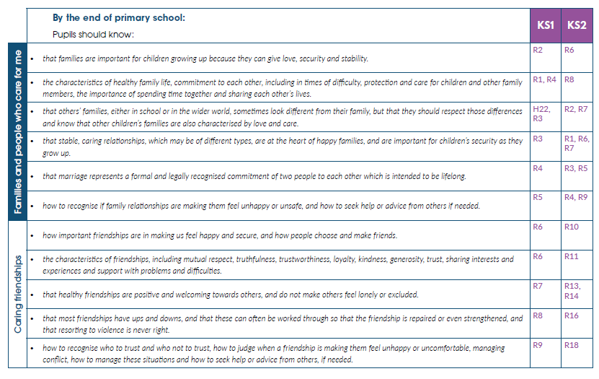

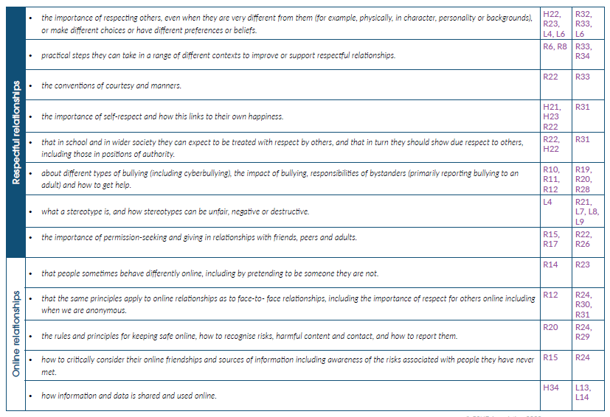

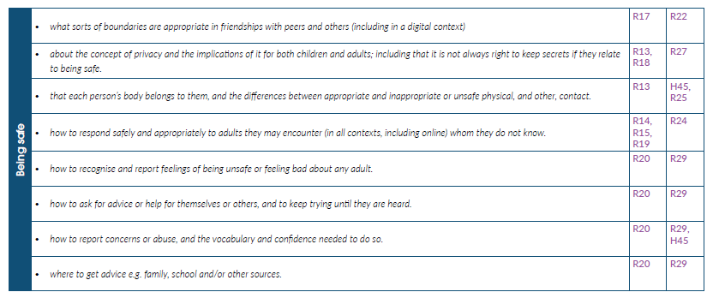

#### HEALTH EDUCATION (PRIMARY)

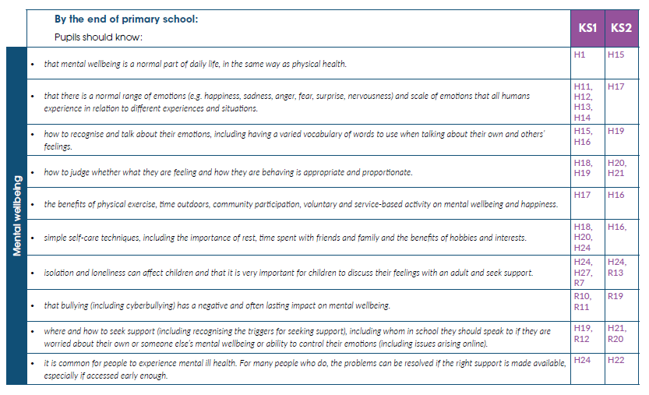

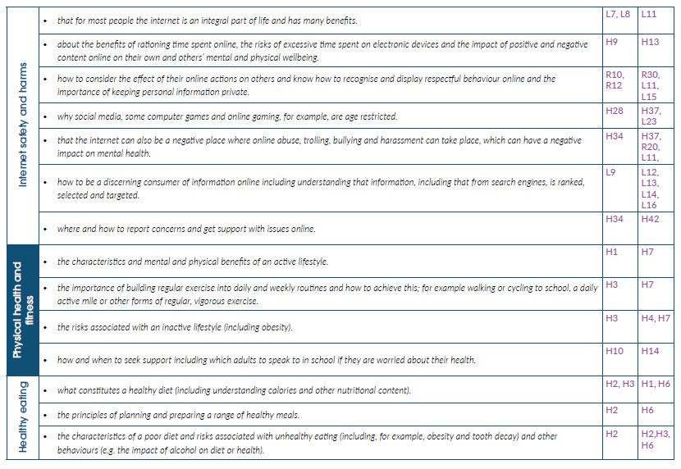

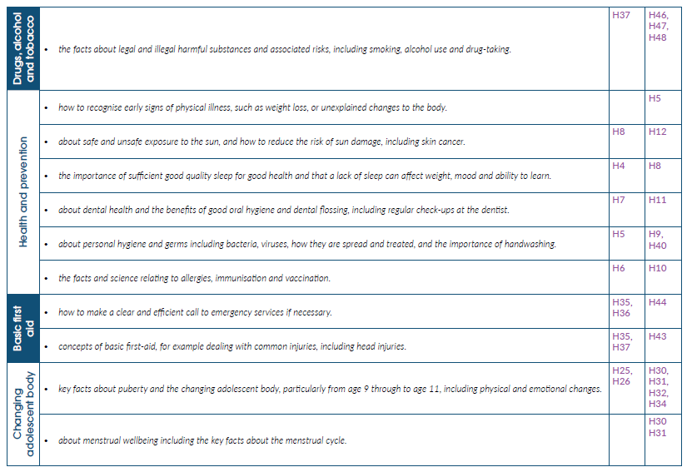

RELATIONSHIPS EDUCATION (SECONDARY)

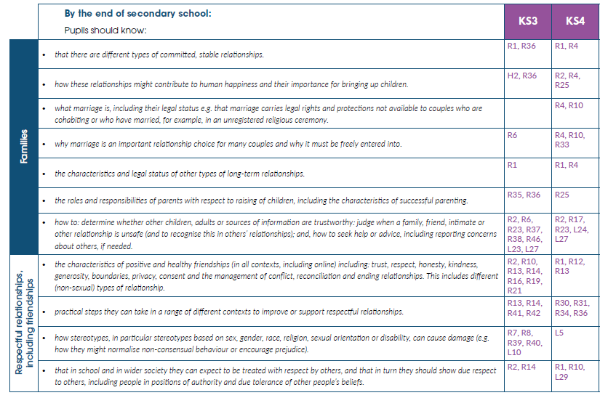

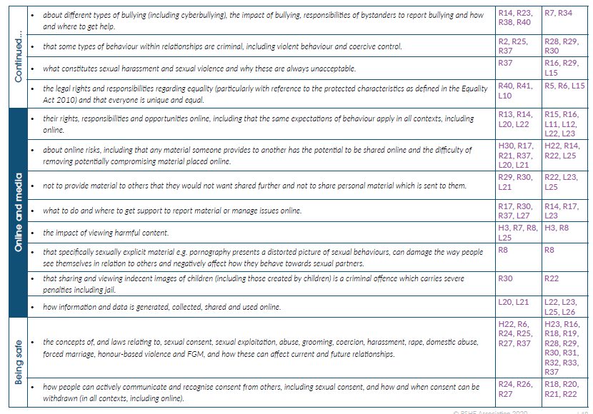

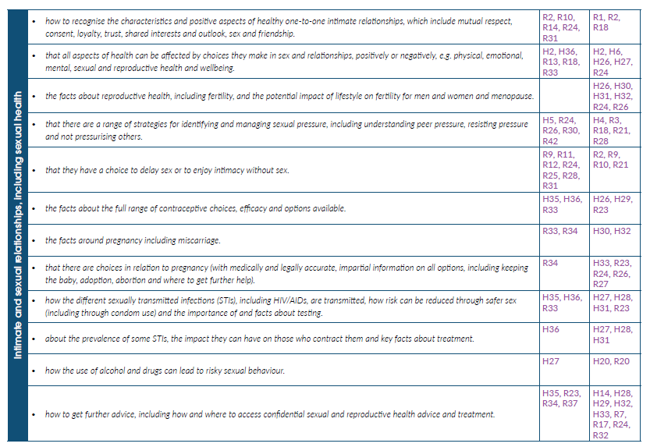

HEALTH EDUCATION (SECONDARY)

