PRESS RELEASE

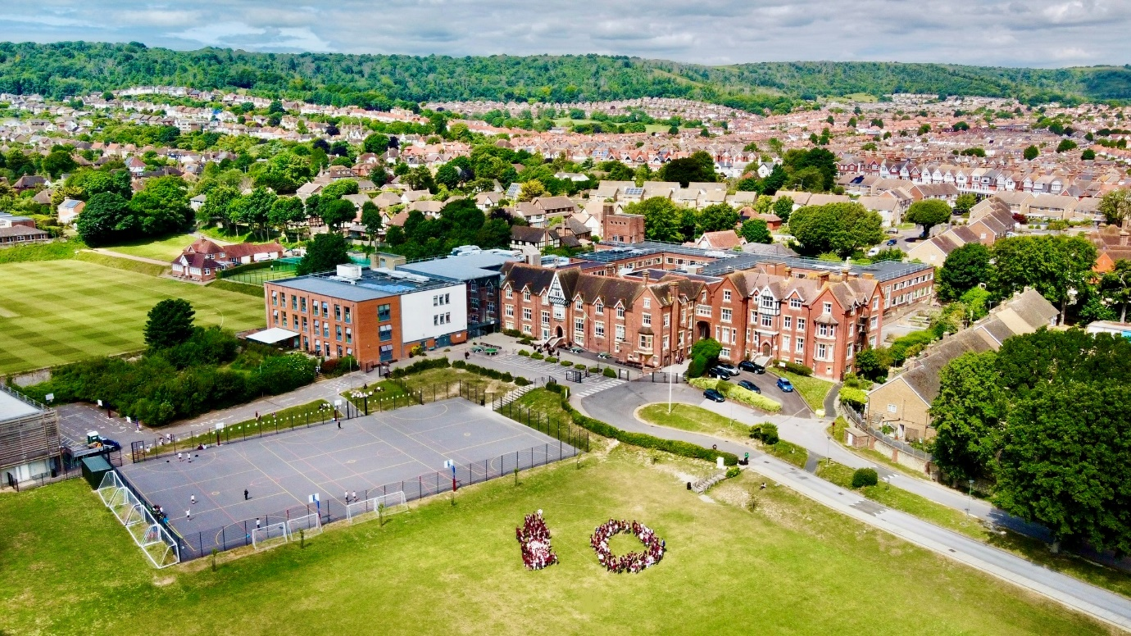
Gildredge House celebrates a decade of educational excellence and growth
Gildredge House proudly marks its tenth anniversary this year, celebrating a decade of educational excellence and a significant contribution to the local community in Eastbourne, East Sussex. Since its founding in September 2013, the school has remained committed to its mission to ‘Aspire’, empowering young people to reach their full potential.
Over the past ten academic years, Gildredge House has provided high-quality education to students aged 4-19 and established itself as a cornerstone of the local community. The school’s commitment to fostering a spirit of ambition and excellence amongst its students is a testament to its belief in the potential of every young person in its community.
Executive Head Teacher, Craig Bull, reflected on the school's journey: "As we celebrate this significant milestone in the school's history, I'm immensely proud of our school's impact on the lives of our students and the wider community. Our commitment to helping every child aspire to greatness in all aspects of their lives has shaped their academic achievements, character, and future prospects. We have seen our alumni go on to make significant contributions in various fantastic fields, truly embodying our mission. This is a testament to the hard work and dedication of the staff and our partnership with parents.” He said about the school’s next chapter, “As Gildredge House embarks on its next decade, we remain steadfast in our commitment to our founding principles and values. We will continue to adapt to meet the evolving needs of our students and the community while staying true to our mission and Aspire values of Ambition, Support, Perseverance, Integrity, Reflection and Empathy.”
The school's influence extends beyond its walls. Numerous community outreach programmes and partnerships have enriched the local area and the lives of its students. From volunteer initiatives such as the Gildredge Give Back to collaborative projects with local businesses, Gildredge House has become an integral part of the community fabric.
Richard Thornhill, Chair of Governors, emphasised the school's impact: "Over the past decade, Gildredge House has not only educated young minds, but the 'Aspire' mission has inspired our students to dream big and work hard, resulting in a new generation of confident, capable, and community-minded individuals. As we look to the future, we are excited to build on this strong foundation and continue to make a difference in the lives of our students and the community at large."
The school prides itself on its community culture and partnership with its families. Mrs McGoldrick, a parent of ten years with two children in the school said “Reflecting back 10 years, I am so happy that we took the leap of faith joining Gildredge House. Our experience has been a truly positive one. The staff work tirelessly to develop encouraging partnerships with the students and parents. I couldn’t be more thankful for the unfailing support and continued guidance shown to my children, which is above and beyond my expectations. Watching the students develop into confident young individuals is a credit to the Senior Leaders and every member of staff who have contributed to this outstanding school.”
As the school looks forward to its eleventh academic year, it prepares to open its doors to prospective parents and students at the upcoming Year 7 Open Evening on Wednesday 25th September 2024, and at the Reception open events on Thursday 7th and Friday 8th November 2024.
Executive Head Teacher, Craig Bull, commented: “We are excited to showcase our school at these open events, when prospective parents and students have the opportunity to experience the warm, welcoming, and inclusive community life at Gildredge House.”
Full details of all upcoming open events will be available on the school website at gildredgehouse.org.uk

